**ASSIGNMENT – II**

**Implement the University Database and execute the given queries/updates University Database Schema:**

Student (ID, name, dept-name, tot-cred)

Instructor (ID, name, dept-name, salary)

Course (Course-id, title, dept-name, credits)

Takes (ID, course-id, sec-id, semester, year, grade)

Classroom (building, room-number, capacity)

Department (dept-name, building, budget)

Section (course-id, section-id, semester, year, building, room-number, time-slot-id)

Teaches (id, course-id, section-id, semester, year)

Advisor (s-id, i-id)

Time-slot (time-slot-id, day, start-time, end-time)

Prereq (course-id, prereq-id)

**Creation of tables and insertion of rows :-**

1. create table Student

(

id number(8),

name varchar2(30),

dept_name varchar2(30),

tot_credits number(3,1)

);

insert into Student values(&id,'&name','&dept_name',&tot_cred);

1. create table Instructor

(

id number(5),

name varchar2(33),

dept_name varchar2(33),

salary number(8)

);

insert into Instructor values(&id,'&name','&dept_name',&salary);

1. create table Course

(

course_id number(5),

title varchar2(33),

dept_name varchar2(33),

credits number(3,1)

);

insert into Course values (&course_id,'&title','&dept_name',&credits);

1. create table Takes

(

id number(5),

sec_id number(5),

year varchar2(5),

semester varchar2(5),

grade char,

course_id number(5)

);

insert into Takes values (&id,&sec_id,’&year’,’&semester’,’&grade’,&course_id);

1. create table Classroom

(

building varchar2(33),

room_number number(4),

capacity number(3)

);

insert into Classroom values (‘&building’,&room_number,&capacity);

1. create table Department

(

dept_name varchar2(33),

building varchar2(33),

budget number(3)

);

insert into Department values (‘&dept_name’,’&building’,&budget);

1. create table Section

(

course_id number(5)

sec_id number(5),

year varchar2(5),

semester varchar2(5),

building varchar2(33),

room_number number(4),

time_slot_id number(9)

);

insert into Section values (&course_id,&sec_id,’&year’,’&semester’,’&building’,

&room_number’,&time_slot_id);

1. create table Teaches

(

id number(5),

course_id number(5),

section_id number(5),

semester varchar2(5),

year varchar2(5)

);

insert into Teaches values (&id,&course_id,&section_id,’&semester’,’&year’);

1. create table Advisor

(

s_id number(5),

i_id number(5)

);

insert into Advisor values(&s_id,&i_id);

1. create table Time_slot

(

time_slot_id number(5),

day varchar2(9),

start_time varchar2(8),

end_time varchar2(8)

);

insert into Time_slot values (&time_slot_id,’&day’,’&start_time’,’&end_time’);

1. create table Prereq

(

course_id number(5),

prereq_id number(5)

);

insert into Prereq values (&course_id,&prereq_id);

**Retrieving records from a table :-**

1. **List all Students with names and their department names.**

**Ans.** select * from Student;

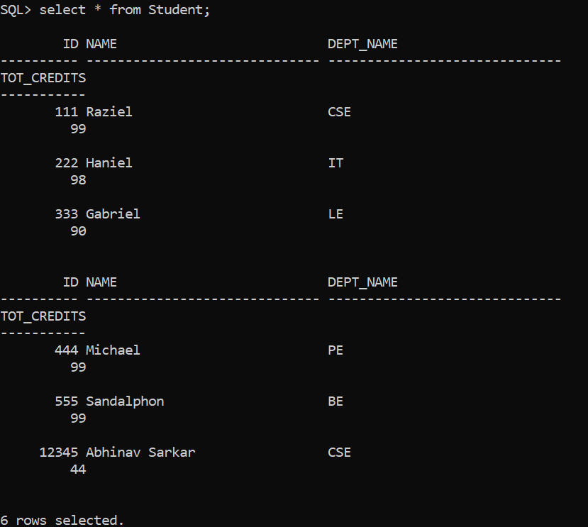

1. **List all instructors in CSE department.**

**Ans.**  select * from Instructor

where dept_name = ‘CSE’;

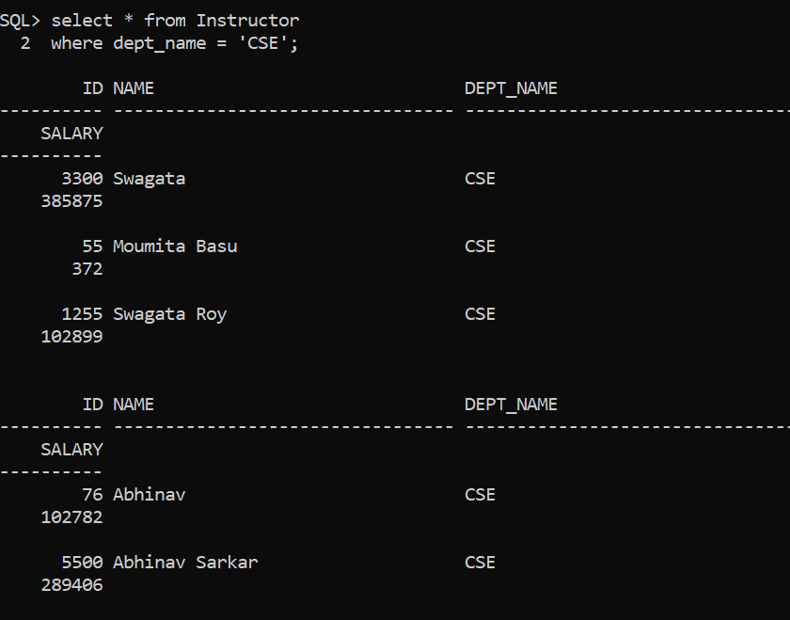

1. **Find the names of courses in CSE department which have 3 credits.**

**Ans.**  select title from Course

where dept_name = ‘CSE’ and credits = 3;

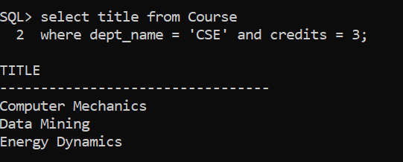

1. **For the student with ID 12345 (or any other value), show total credit for the student.**

**Ans.**  select tot_cred from Student

where id = 12345;

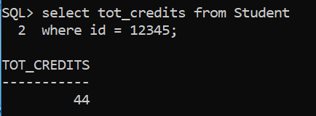

1. **List all the instructors whose salary is in between 40000 and 90000.**

**Ans.** select * from Instructor

where salary >= 40000 and salary <= 90000;

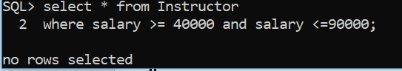

**Updating records from a table :-**

1. **Change the advisor id of students with id between 100 and 200 to 1001.**

**Ans.**  update Advisor

set i_id = 1001

where s_id >= 100 and s_id <=200;

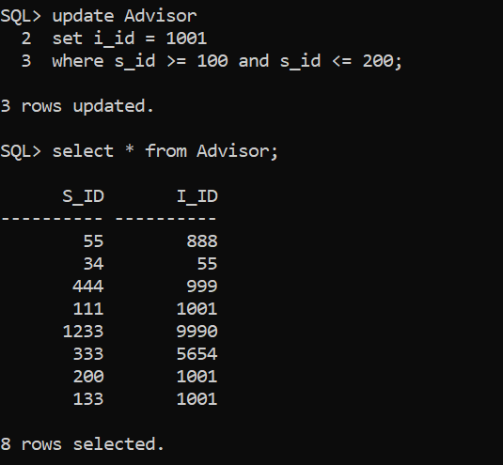

1. **Transfer all the instructors of IT department to CSE department.**

**Ans.** update Instructor

set dept_id = ‘IT’

where dept_id = ‘CSE’;

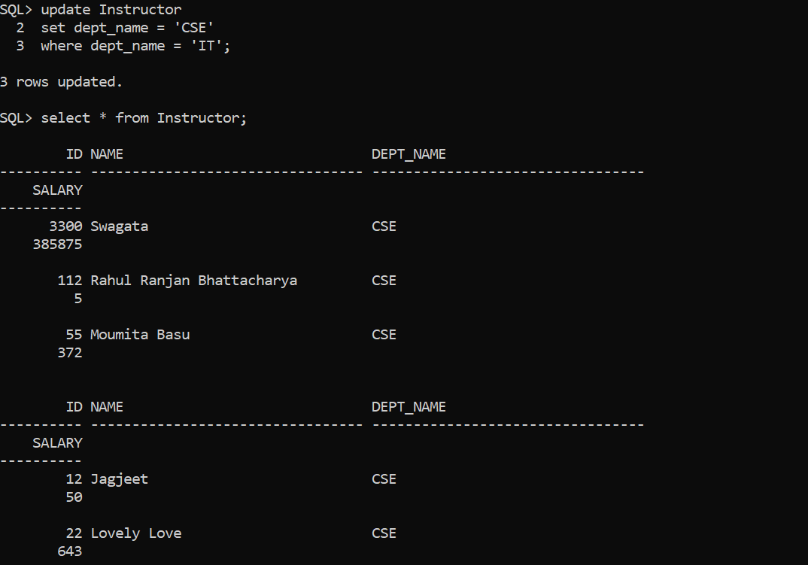

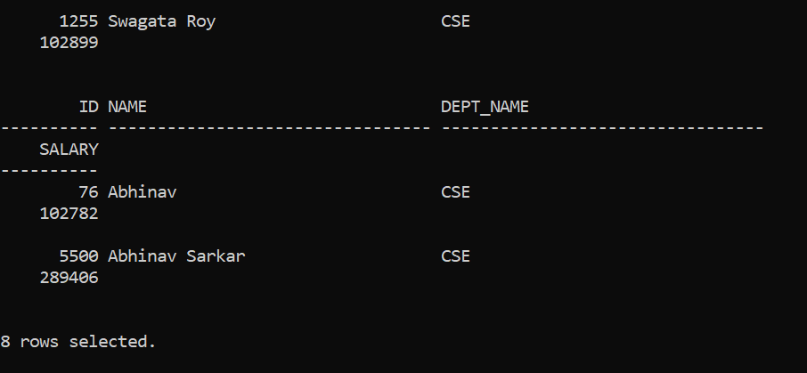

1. **Raise the salary of all the instructors by 5%.**

**Ans.** update Instructor

set salary = salary + salary * 0.05;

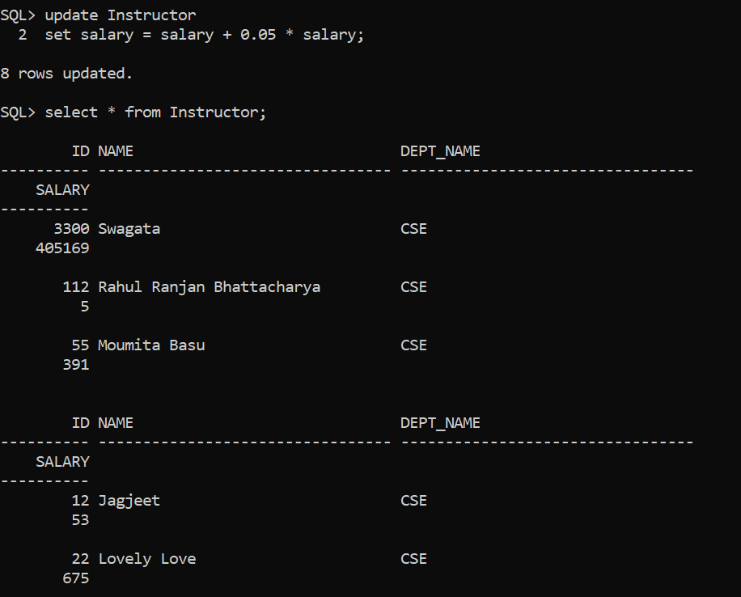

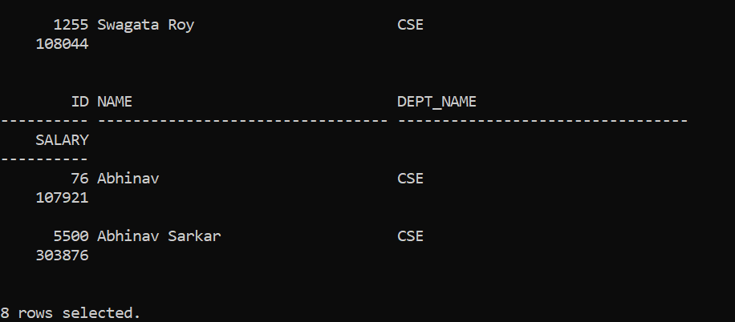

**Deleting records from a table :-**

1. **Delete the IT department.**

**Ans.** delete from Department

where dept_name = ‘IT’;

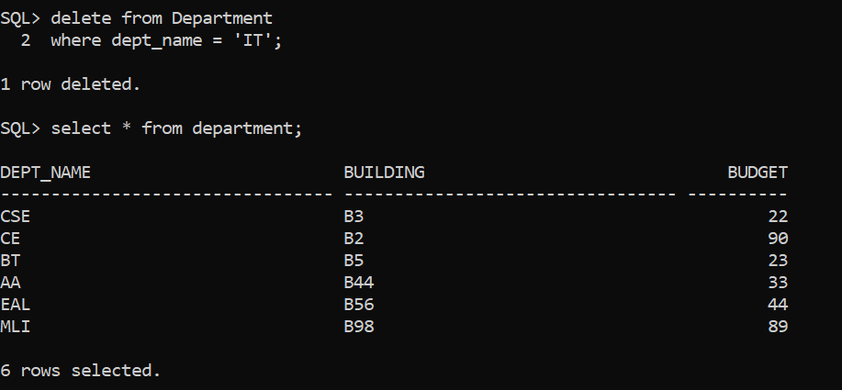

1. **Waive off perquisite for the course with course id 101.**

**Ans.** delete from Prereq

where course_id = 101;

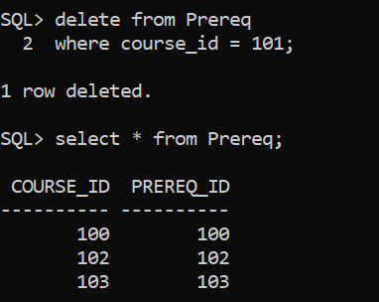

**Modifying the structure of tables :-**

1. **Add a column Date_of_birth to student table.**

**Ans.** alter table Student

add Date_of_birth varchar2(10);

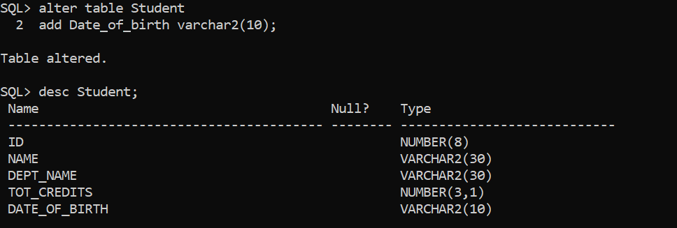

1. **Change the size of the dept-name to varchar (20).**

**Ans.**  alter table Department

modify dept_name varchar(20);

